**MOBILE SERVICE MANAGEMENT SYSTEM (MSMS)**

**MAHIMA ANANTH CHOWDARY**

**https://github.com/mahesh279/database-systems.git**

**11/04/2022**

**Week4**

In continuation from wk3 the below mentioned are the outcomes for wk4.

# 1. Vertabelo table structure

## MSMS-image

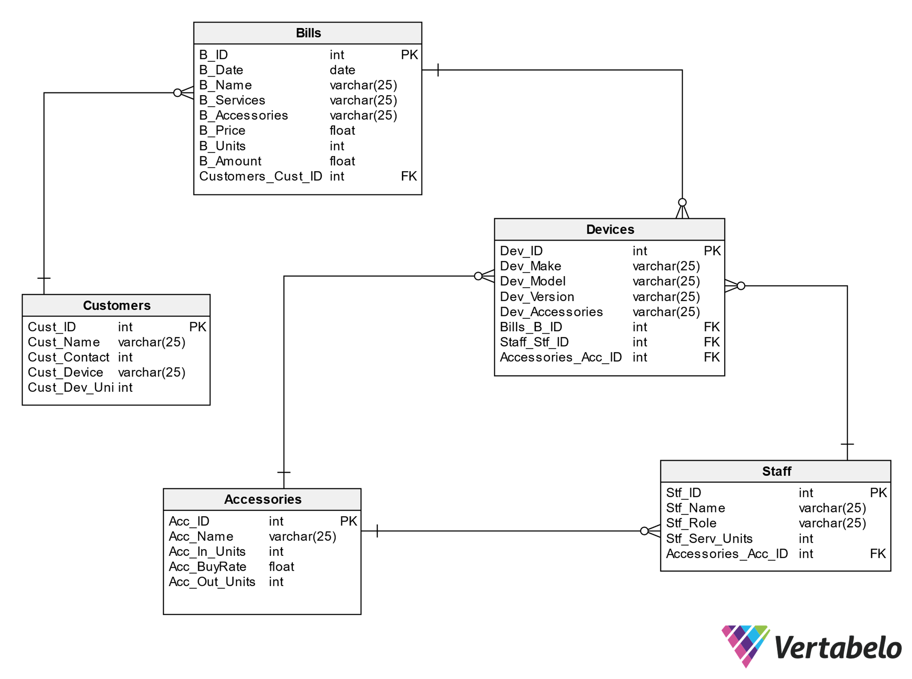

## MSMS-Model Documentation



## Export model to PDF file



## Generate SQL script



## Commands to create my databases



## **INSERT INTO**

INSERT INTO `accessories` VALUES (4001, 'RAM', 218, 20, 76, 5001, 2001);

INSERT INTO `accessories` VALUES (4002, 'Bluetooth', 315, 30, 118, 5002, 2002);

INSERT INTO `accessories` VALUES (4003, 'ScreenGuard', 173, 40, 89, 5003, 2003);

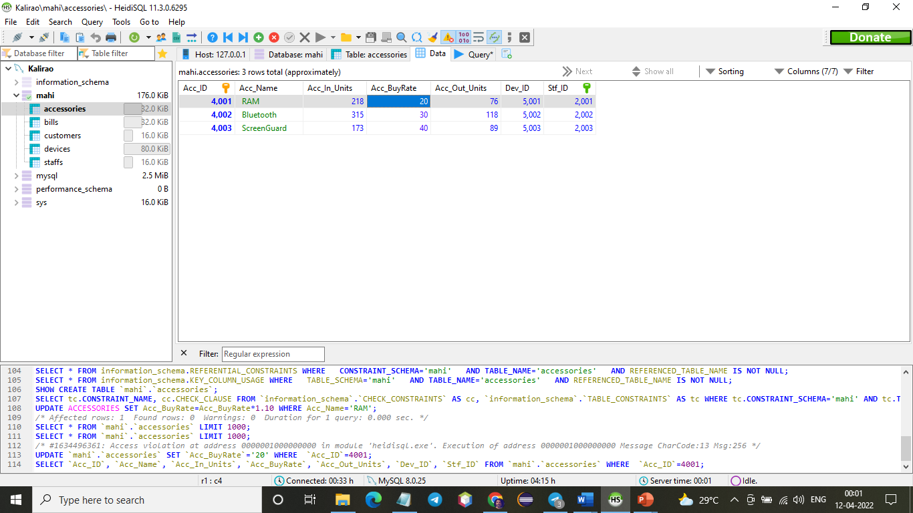

INSERT INTO `bills` VALUES (3001, '2022-04-11', 'Murugan', 'Apple', 'Bluetooth', 50, 1, 55, 1001);

INSERT INTO `bills` VALUES (3002, '2022-04-11', 'Ram', 'Samsung', 'Ram', 75, 1, 83, 1002);

INSERT INTO `bills` VALUES (3003, '2022-04-11', 'Jacob', 'Oppo', 'Screen guard', 10, 1, 11, 1003);

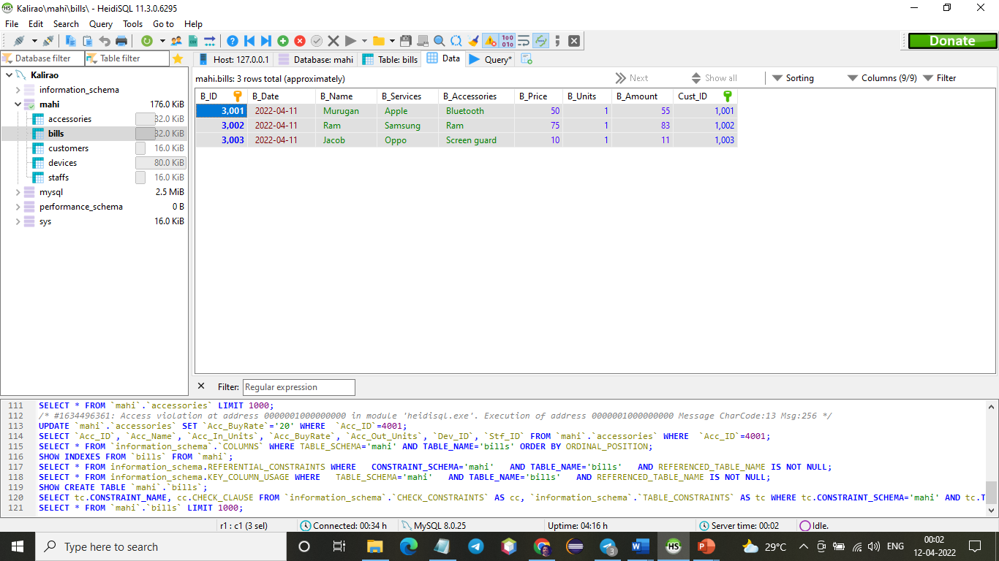

INSERT INTO `customers` VALUES (1001, 'Fransis', 12345, 'Oppo', 1);

INSERT INTO `customers` VALUES (1002, 'Ruby', 23456, 'Samsung', 1);

INSERT INTO `customers` VALUES (1003, 'Jenniefer', 34567, 'Apple', 1);

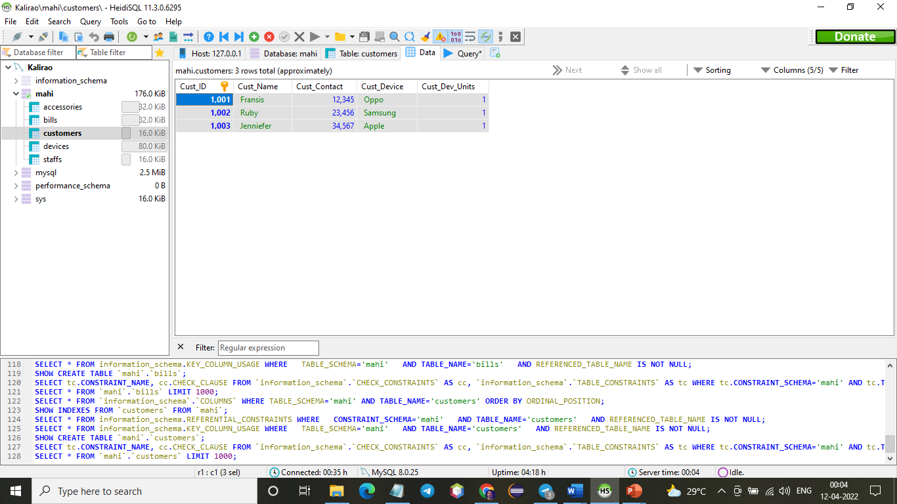

INSERT INTO `devices` VALUES (5001, 'apple', 'v13', '10c', 'Bluetooth', 1001, 2002, 4002, 3003);

INSERT INTO `devices` VALUES (5002, 'samsung', 'g10', '11a', 'RAM', 1003, 2003, 4001, 3001);

INSERT INTO `devices` VALUES (5003, 'oppo', '011', '9G', 'ScreenGuard', 1002, 2001, 4003, 3002);

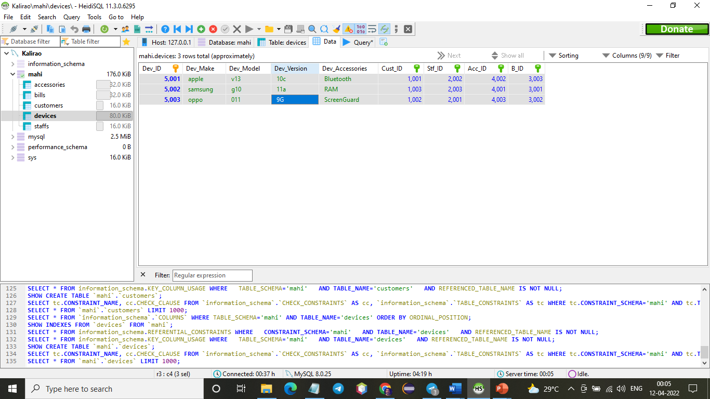

INSERT INTO `staffs` VALUES (2001, 'Lorenz', 'Technician', 28);

INSERT INTO `staffs` VALUES (2002, 'Decaprio', 'Supervisor', 70);

INSERT INTO `staffs` VALUES (2003, 'Selena', 'Technician', 20);

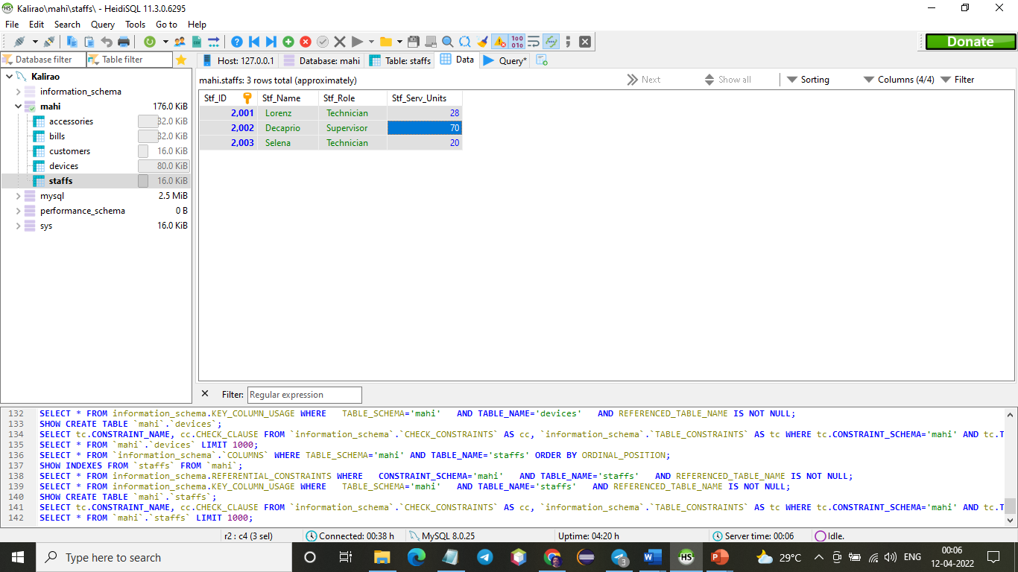

## **Update Statement – before applying affect**

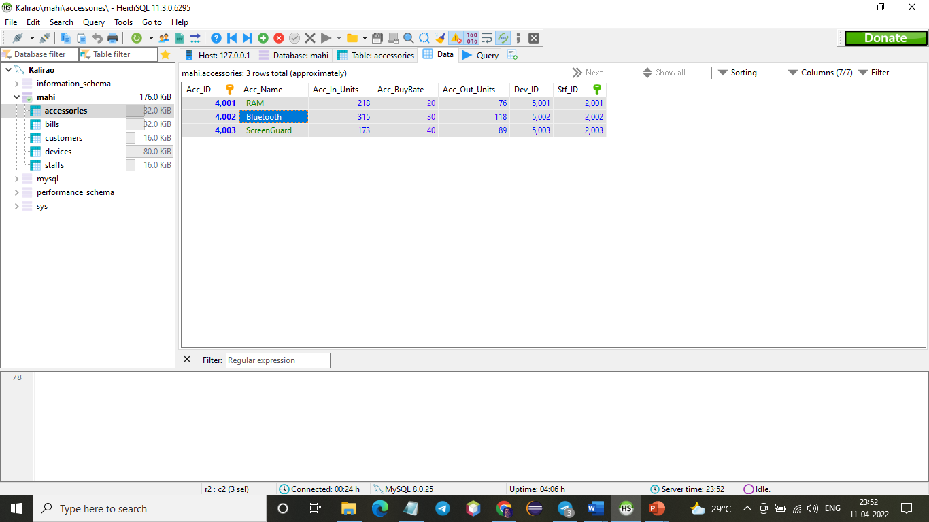

## **Update Statement – after applying affect**

UPDATE ACCESSORIES SET Acc_BuyRate=Acc_BuyRate*1.10 WHERE Acc_Name='RAM';

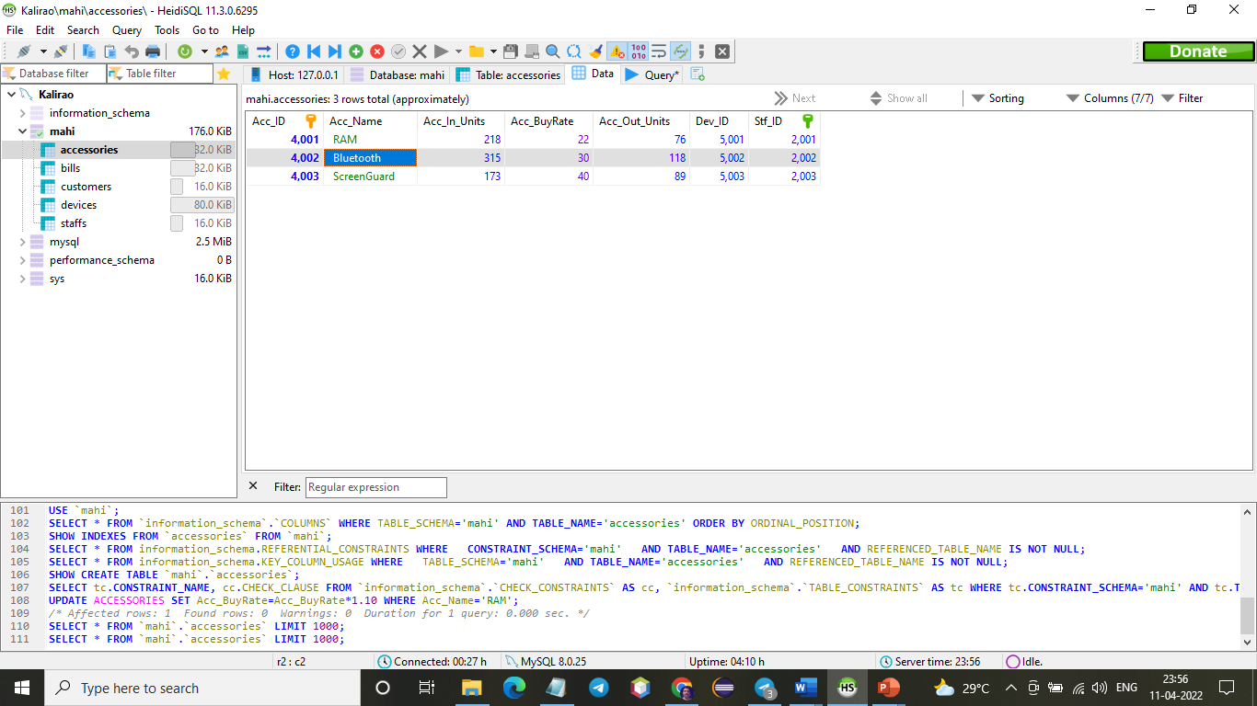

## **Delete Statement**

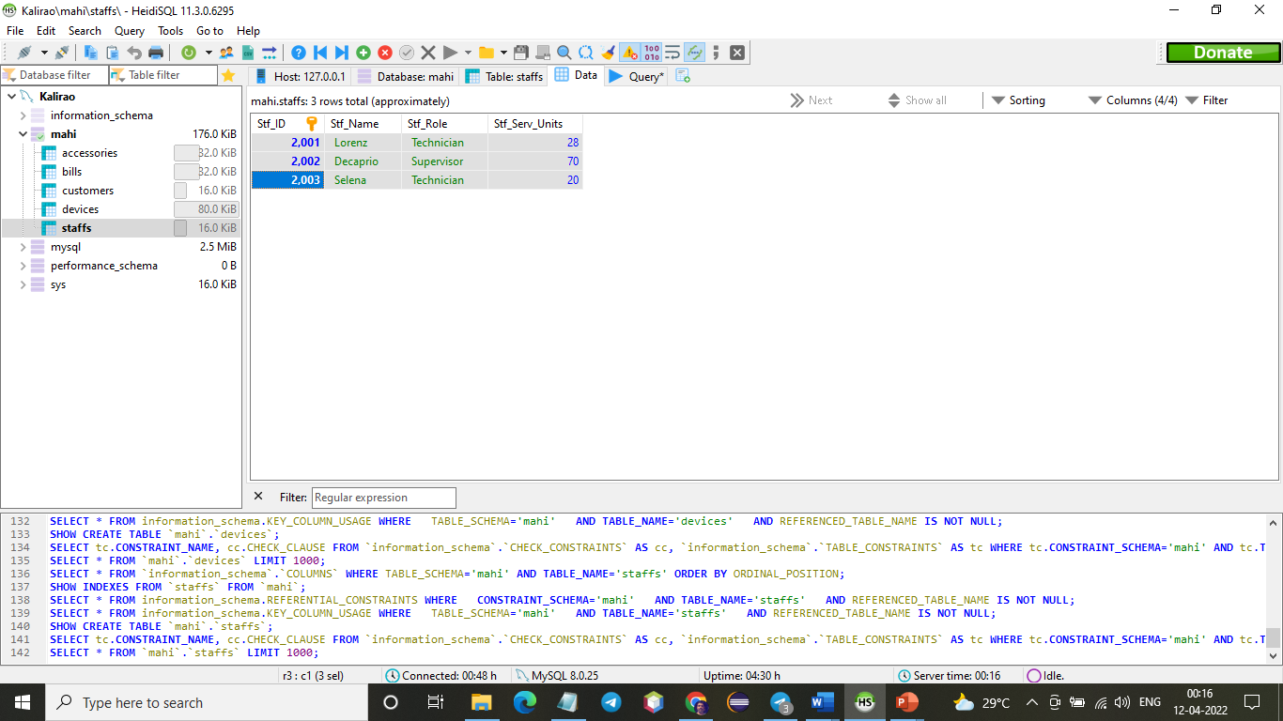

**DELETE** **FROM** Staff **WHERE** Stf_ID=2003;

It gives error because a foreign key constraint fails.

Yes, this record can be deleted in two ways.

1. before foreign key implemented.
2. After foreign key with cascade (here cascade delete means if a record in the parent table deleted then corresponding child table records have a subsequent affect)

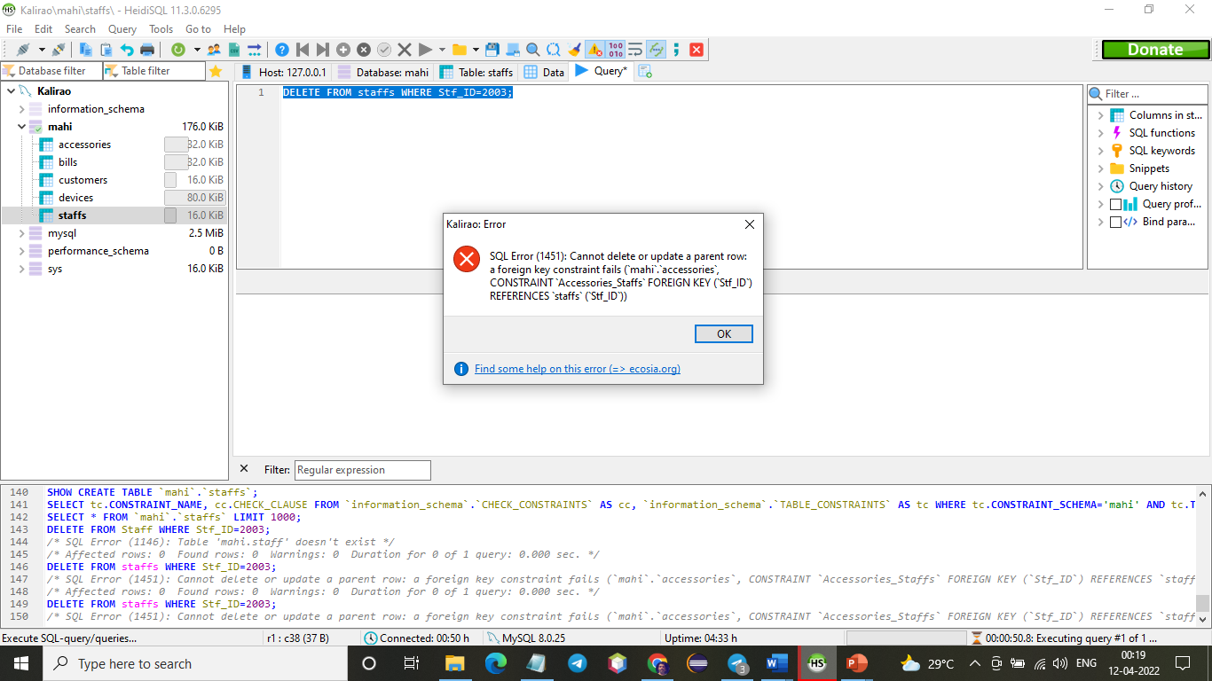

## Select Statement

**SELECT** * **FROM** staffs;

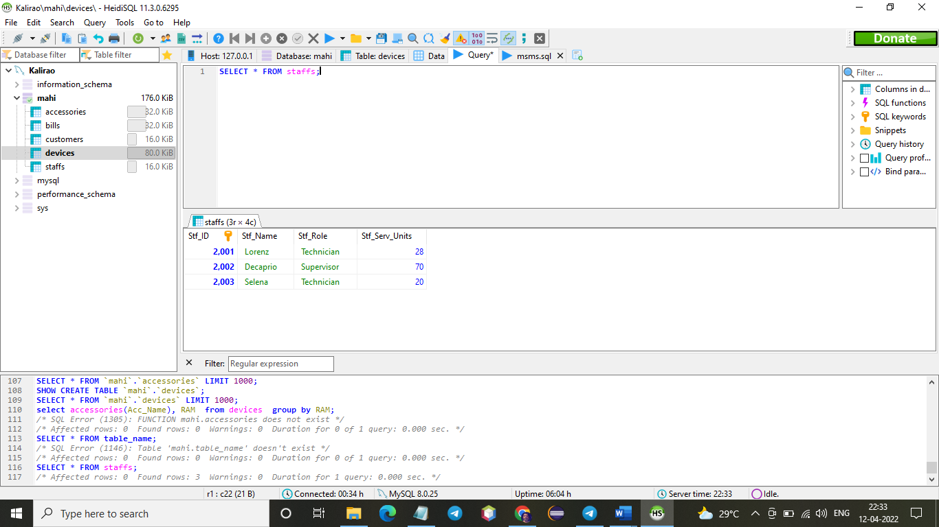

## **Inner Join**

**select** accessories.Acc_ID, accessories.Acc_Name

**from** accessories

**inner** **join** bills

**on** accessories.Acc_Name=bills.B_Accessories;

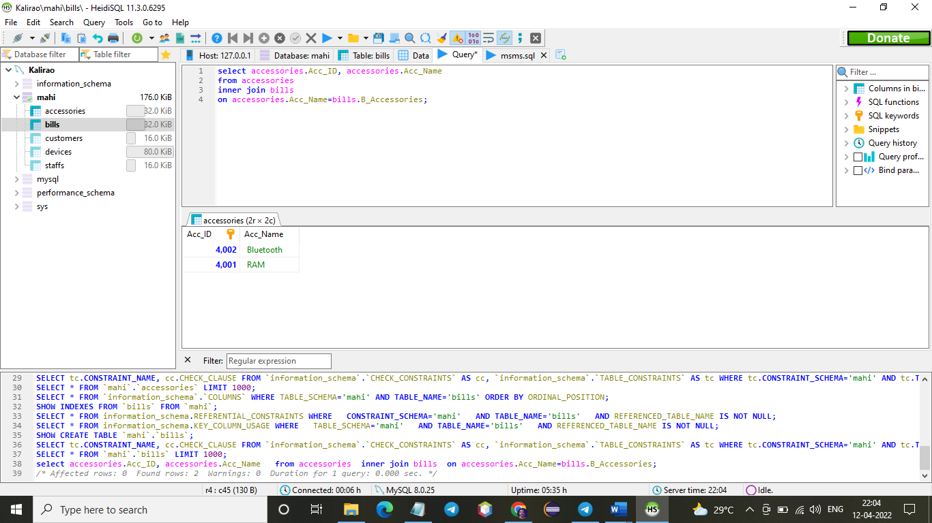

**select** devices.Dev_Accessories, Dev_Make, accessories.Acc_Name

**from** devices

**inner** **join** accessories

**on** devices.Dev_Accessories=accessories.Acc_Name;

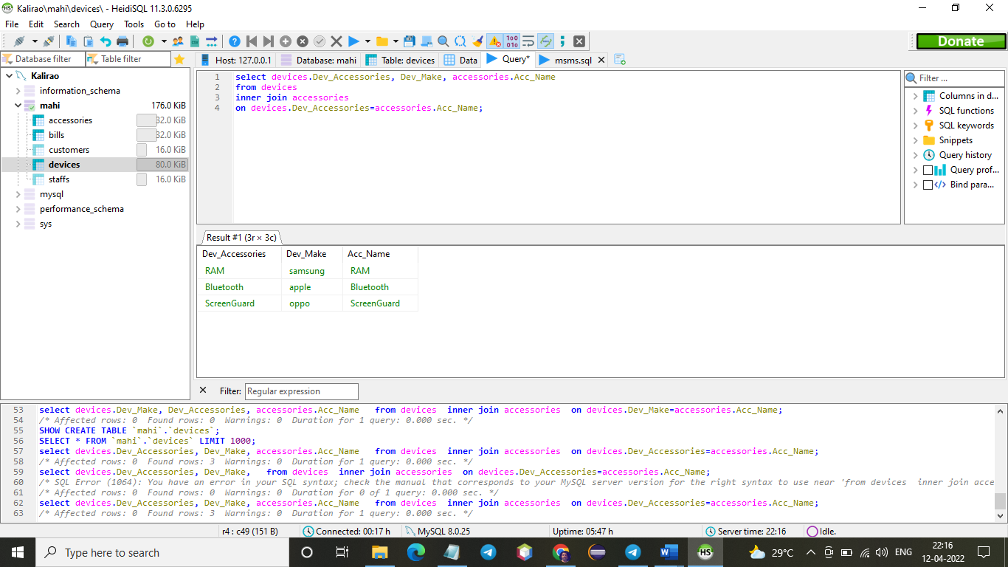

## Summary statements

### **GROUP BY**

**SELECT** **COUNT**(Stf_ID), Stf_Role

**FROM** staffs

**group** **by** Stf_Role;

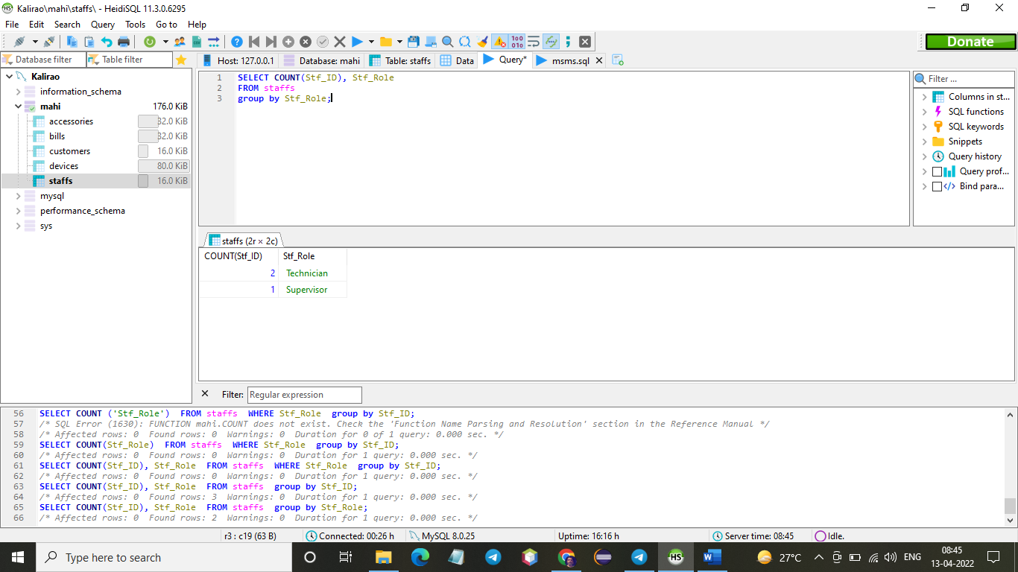

**SELECT** **MAX**(Stf_ID), Stf_Role

**FROM** staffs

**group** **by** Stf_Role;

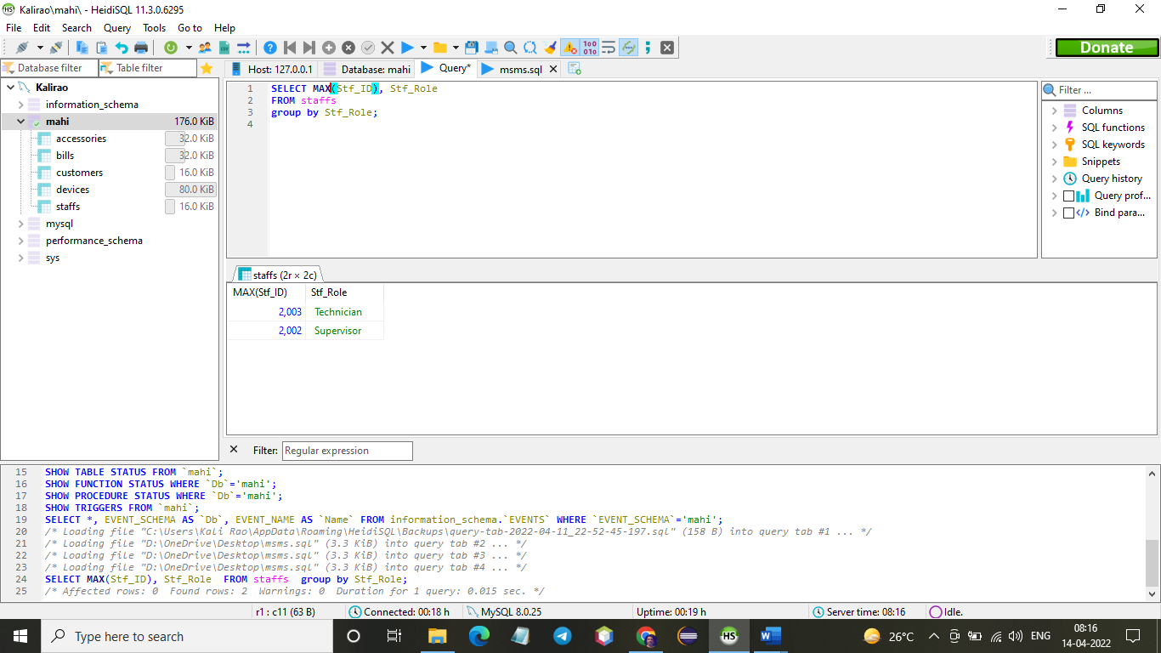

### HAVING

**SELECT** **COUNT**(Dev_ID), Dev_Make

**FROM** devices

**group** **by** Dev_Make

**HAVING** Dev_Make='Apple';

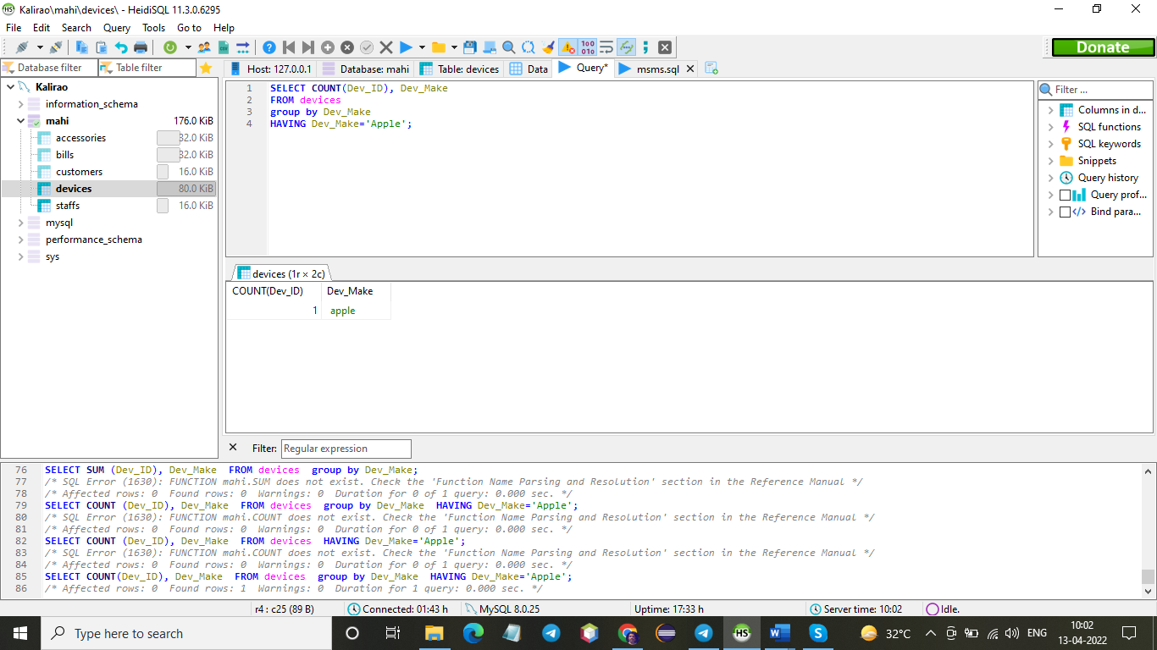

### **MULTIPLE TABLE QUERY**

**SELECT** bills.B_ID, customers.Cust_Name

**FROM** customers

**INNER** **JOIN** bills

**ON** customers.Cust_ID = bills.Cust_ID

**ORDER** **BY** B_id;

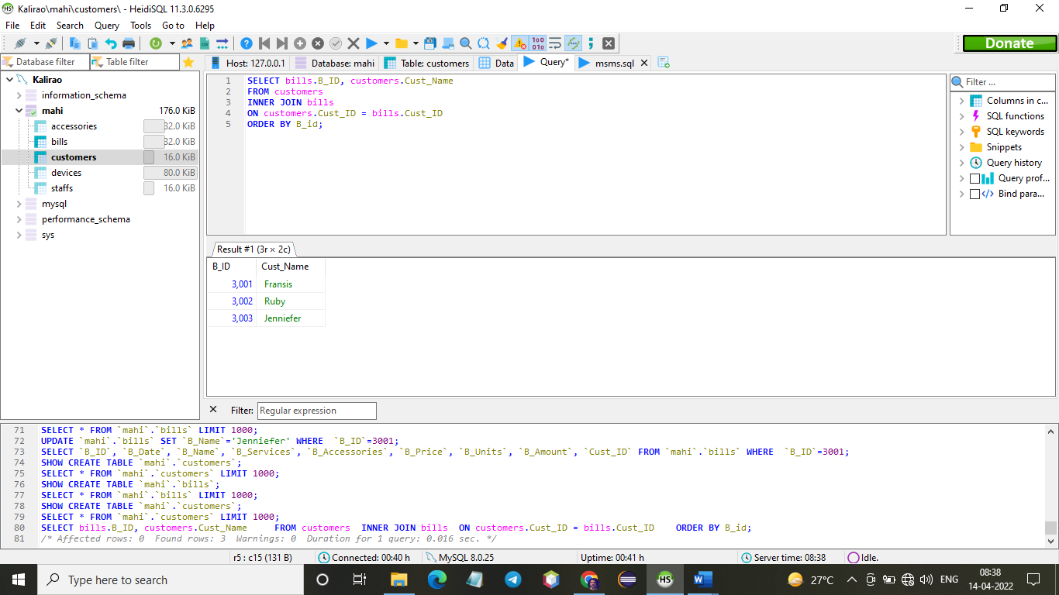

### **REPLACE COMMANDS**

REPLACE INTO `accessories` (`Acc_ID`, `Acc_Name`, `Acc_In_Units`, `Acc_BuyRate`, `Acc_Out_Units`, `Dev_ID`, `Stf_ID`) VALUES

(4001, 'RAM', 218, 20, 76, 5001, 2001),

(4002, 'Bluetooth', 315, 30, 118, 5002, 2002),

(4003, 'ScreenGuard', 173, 40, 89, 5003, 2003);

REPLACE INTO `bills` (`B_ID`, `B_Date`, `B_Name`, `B_Services`, `B_Accessories`, `B_Price`, `B_Units`, `B_Amount`, `Cust_ID`) VALUES

(3001, '2022-04-11', 'Murugan', 'Apple', 'Bluetooth', 50, 1, 55, 1001),

(3002, '2022-04-11', 'Ram', 'Samsung', 'Ram', 75, 1, 83, 1002),

(3003, '2022-04-11', 'Jacob', 'Oppo', 'Screen guard', 10, 1, 11, 1003);

REPLACE INTO `customers` (`Cust_ID`, `Cust_Name`, `Cust_Contact`, `Cust_Device`, `Cust_Dev_Units`) VALUES

(1001, 'Fransis', 12345, 'Oppo', 1),

(1002, 'Ruby', 23456, 'Samsung', 1),

(1003, 'Jenniefer', 34567, 'Apple', 1);

REPLACE INTO `devices` (`Dev_ID`, `Dev_Make`, `Dev_Model`, `Dev_Version`, `Dev_Accessories`, `Cust_ID`, `Stf_ID`, `Acc_ID`, `B_ID`) VALUES

(5001, 'apple', 'v13', '10c', 'Bluetooth', 1001, 2002, 4002, 3003),

(5002, 'samsung', 'g10', '11a', 'RAM', 1003, 2003, 4001, 3001),

(5003, 'oppo', '011', '9G', 'ScreenGuard', 1002, 2001, 4003, 3002);

REPLACE INTO `staffs` (`Stf_ID`, `Stf_Name`, `Stf_Role`, `Stf_Serv_Units`) VALUES

(2001, 'Lorenz', 'Technician', 28),

(2002, 'Decaprio', 'Supervisor', 70),

(2003, 'Selena', 'Technician', 20);

